 | Dimensional Innovations – The 3-D Print LSAM: Opportunity or Dilemma?  Design, Make, Innovate
Between a stretch of Merriam Drive and railroad tracks in Overland Park lie the offices of Dimensional Innovations. With concrete slab walls studded with docks, it looks like a million other industrial buildings --- until you go inside.

Dimensional Innovations is a magic place where imagination becomes reality. On any given day, employees may be working on a replica of Death Star from “Star Wars”, a giant goalie mask, or a dinosaur. Technology adds another dimension to the company’s work. An interactive exhibit for a museum combines a motorcycle with virtual reality technology to let people experience jumping the bike over buses like Evel Knievel. For another project, a 360-degree video let’s users see what it’s like to skydive without ever leaving the ground. Dimensional Innovation’s own story is as dream-come-true as some of its projects.

In mid-April, 2019 the greater-Kansas City-based Dimensional Innovations (DI) took delivery of an LSAM (L-Sam or Large Scale Additive Manufacturing system, 3-D printing system). Thermwood Corporation, a 50-year-old Indiana-based manufacturing firm, had designed and manufactured the printing system. Thermwood was a major supplier of CNC (computer numeric controlled) traditional manufacturing equipment. The firm was taking the lead in developing 3D/additive printing technologies about 2016 and had begun to develop a series of patents related to 3D printing. The LSAM printer, like others Thermwood produced, used carbon-fiber reinforced thermoplastic composite materials as its “printing” material. The LSAM could produce “…large to very large reinforced thermoplastic composite parts” through a “…two-step, near-net-shape production process.” Companies in aerospace, automotive, boating, foundry, and other thermoforming industries were looking for equipment that could produce “…large-scale tooling, masters, molds, fixtures, patterns, and plugs”. However, in early 2019 there were very few large-scale 3-D printers available.

The LSAM was the largest 3-D printer available for printing with carbon fiber reinforced thermoplastic materials. It could print shapes, parts or completed products, up to 10’ high, five feet wide, and 100 feet long.

In a meeting in mid-April, just before the printer’s delivery day, Dimensional Innovations (DI) CEO Tucker Trotter and COO Tom Collins talked over coffee. Collins was looking at the brochure from Thermwood that depicted the 3-D printing machine to be delivered the following week. Collins said, “Well, you saw---we have the space for the LSAM all ready in the back.” Trotter mused, “That is the largest investment we have made to date. When the project we bought the LSAM for is completed later this year, we have to have the plans to utilize laid down carefully and be ready to go to market with its capabilities. We haven’t let grass grow under our feet when opportunities have arisen in the past and the 3-D printer is no different. We need to start generating a revenue stream from this investment --- a profitable revenue stream.”

DI-History

Jim Baker founded Dimensional Innovation (DI) in 1993 with three business partners. Baker had already been successful in commercial photography and was owner of a photography lab. Like many startups, DI began in the founder’s garage. The company’s 1993 origins as a sign shop were modest --- as the company put it, “A small space with an equally small client list.” In 1994 along with two partners, Baker and his three business partners incorporated the company as Schofield Design. (See Appendix #A for a Company Timeline 1993-2017.)

Schofield got its first big break in 1995 with AMC Entertainment Inc., a major motion picture theater company headquartered in Kansas City. The motion picture theatre industry had entered a period in which the theatres the competition among the industry entrants heated up and cinema companies needed help. AMC asked Jim Baker to design interior signage and themed architectural décor. Between 1995 and 1998, DI completed 60 projects for AMC. The AMC projects were DI’s “bread and butter” company in these years. CEO Trotter reported ultimately being in involved in 200 cinema projects. However, in the late 1990s, the motion picture industry ceased the multiplexing craze that had fueled the building and renovation activities. As a result, DI’s stream of work dried up and, in response, the company broadened its client base.

Trotter had originally joined the company in 1995 as its first intern. At the time, he was midway through his University of Kansas program pursuing a Bachelor of Fine Arts in Industrial Design. After graduation Trotter founded a firm called Outdoor Innovations, a firm that had several patents on consumer products related to the automotive industry.

Trotter came back to Dimensional Innovations in 1996. Within a year, he became a partner in the firm. Over the next several years, Trotter was involved in numerous DI project that ultimately resulted in work with over 200 cinematic theatres and expanded the firm into pro and collegiate sports, along with major installations in museums, halls of fame, and entertainment districts across the country.

By 2005 the company had 70 employees including 10 engineers; six artists with a variety of skills; fabricators who worked in a broad array of medium including foam and metal; and a marketing team that worked on building DI’s world-wide network of relationships with architectural and development firms. DI had invested in what a local reporter described as:

…lots of expensive high-tech equipment, such as the high-resolution printer that cranked out the 25-foot-tall book spines for the library and giant dinosaur pictures for Science City's new Dino Lab exhibit. The facility also houses three computer-operated routers, which carve out pieces for digitally designed, three-dimensional projects -- such as the floatplane replicas it makes for Scheels All Sports stores.

In the middle of the first decade of the Twenty-First Century, Trotter described his firm as "a signage and specialty architectural fabrication business." At the time, the company's motto was "If you can dream it, we can build it." DI had won many awards for its designs and installations, commendations from client companies and users alike, and had been a noticeable growth company. The firm ended 2018 with revenues slightly more than $40M and an A+ credit rating. (See Exhibit #1 below for selected financial information.)

Dimensional Innovations – Exhibit #1
Selected Financial Information 2016-2018
 | 2016 | 2017 | 2018
Revenue | $ 32,000,000 | $ 36,000,000 | $ 40,000,000
Direct Margin % (of Rev) | 50% | 48% | 51%
EBITDA % (of Rev) | 5% | 6% | 10%
Total Assets | $ 11,500,000 | $ 13,500,000 | $ 15,000,000
Note: Author's Estimates

By early 2019 DI’s capabilities and processes had evolved to include design, technology, engineering, and custom fabrication. The company’s workforce included nearly 250 employees with a variety of skills contributing to these processes. (See Appendix #B for backgrounds of DI’s senior executives.) DI’s CEO was Tucker Trotter whom COO Tom Collins described “the guiding vision” behind DI’s success. Collins went on to explain that Trotter was “…always asking what’s next and what can we do to improve the customer experience and the user experience.”

DI’s Business Model

DI was essentially a designer of special displays and interiors. In addition, the firm had the capabilities to build most of its designs in house. DI could be basically described as a “design-build” firm. However, that moniker belied the complexity of describing the company. As CEO Tucker Trotter put it, describing what kind of business DI was “…one of our biggest challenges.” The company’s business operated primarily in the Sign Manufacturing (SIC #3393-02 and NAICS #339950) arena, but also had its foothold in Designers-Industrial (SIC #1541-02), Display Designers and Producers (SIC#7319-01), Industrial Building Construction (NAICS#236210), and Outdoor Advertising (NAICS#541850). Its projects were primarily for commercial and industrial firms. The company had completed projects at the local, regional, and national levels. Although the company generally stayed away from RFP work, it had undertaken some government projects at various levels.

The DI Process and Technologies

Dimensional Innovations eschewed the usual Design-Bid-Build (D-B-B) process and, instead, worked in partnership with its clients in a Design-Build Process. As DI pointed out, the D-B-B process consisted of as many as 17 steps including initial design, putting to bid, discovery of over-budget situation, redesign, negotiation, new drawings, build (manufacture/assembly), install, and punch list (check off list to see that all items included in the bid were completed satisfactorily). Instead, DI utilized a six-step “Experience design” process. Within each phase, the firm worked closely with its clients. Aspects of each of these phases --- 1) discovery, 2) concept design, 3) design development, 4) construction documents, 5) fabrication & install, and 6) launch --- appear in Appendix #C. An explanation of experience design appears in Appendix #D. DI pointed out to potential clients that:

Even though it’s now a buzzword, the practice of experience design has been a long time coming. And for DI, experience design is not a hot business we jumped into, but a modern discipline we’ve been growing into since our inception in 1993.

It’s really about defining the purpose before designing the place. We look at the story of your space, think about your audience first, and with all the tools at our disposal, create a journey that will cause a desired effect. Amazement. Curiosity. Loyalty. Talk value. Commerce.

The Experience Design process involved brainstorming with clients, designing their visions and fabricating them into reality. Among the purposes of the process was to understand and undertake “brand activation”, i.e., bring a firm’s brand to life by checking such issues as:

- How the brand looks
- How it feels within a physical space
- Whether the brand
  - Engages its audience
  - Inspires loyalty among customers
  - Is memorable.

In all of its projects, DI’s purpose was to bring its clients’ brands to life, to tell the story, connect the client firm with its audiences, grow the client’s business and provide guidance for the direction the firm would follow for the future. As an example, DI pointed out “…a sports arena must engage fans beyond the game with surroundings, sponsorship activations and moments in time that surprise, delight and inspire.”

To achieve bringing its clients’ brands to life, DI designed spaces and displays that incorporated a variety of technologies such as OLED touch screens and virtual reality displays. Electronics also included items such as innovative and inviting touch screens that both entertained, informed, and, above all, engaged.

In some instances, the client design might include a single object such as the “playable” 12-foot 500-pound playable guitar with a frame of Medium Density Framework or MDF wood casing and steel with electronically generated sound. The guitar was a popular attraction during the June 2017 two-day family friendly Boulevardia Fest in Kansas City. The guitar used the computer-based program Garageband for generating the guitar sounds. (See Appendix #E for this and other DI projects.)

Other projects included complete interior physical spaces within the locations the clients designated. The design of the physical space might the ambience plus electronic and other physical objects. Ambience included the interior design of walls, floors, and interior layout.

Other tangible objects might include objects such as the motorcycle that formed part of the Virtual Reality display in the Evel Knievel Museum. The motorcycle and virtual reality projection allowed the museum visitor to “ride” the motorcycle in a jump over cars. As the DI put the results of its efforts:

“At DI, experience design goes far beyond a touch screen. Our “big picture” thinking elevates experiences, making them more engaging, more informational, more inspirational and a heckuva lot more fun.”

By 2019 DI been involved in fabrication to “…make the coolest designs come to life.” The “cool” designs included the world’s largest hockey helmet, a massive Death Star, and two-story pouring milk sculpture. One of the firm’s motto was “Think it can’t be done? Try us.”

DI explained to potential clients that the firm wanted to understand the users’ “entire experience and how it works within the environment.” Doing so enabled DI to “…deliver reliable long-term solutions on time and on budget” with the company’s strength lying in “…program management, with dedicated teams managing entire rollouts.” DI was clearly proud of its system that was “…proven to work and (enable the company)… to maintain multiple on-going relationships through transparent communication and trust.”

Market Segments Served

DI’s focus on signage began in 1993 with its founding. The firm moved into architectural design with its first AMC project. The firm subsequently diversified into pro and collegiate sports in 2002 and subsequently into retail, health care, museum, civic, and transit projects. (See Appendix #E for profiles of trends in four major markets and selected DI projects.) On occasion, the company was asked to help with projects in which the client and architect were at loggerheads. One such example was the Kansas City Central Branch Public Library garage wall. DI designed the façade for the wall of the library’s garage. The façade was made up of 25’ by 9’ book spines made of signboard Mylar that DI had designed and printed. Kansas City readers suggested titles as part of a program to beautify the central downtown. The Kansas City Public Library Board of Trustees selected 22 titles to represent a variety of interests. The book spine titles included The Lord of the Rings" (by J. R. R. Tolkien); Fahrenheit 451 (Ray Bradbury); Charlotte’s Web (E.B. White); and Silent Spring (Rachel Carson).

Wayfinding. DI also paid careful attention to projects calling for “wayfinding”. DI learned the principles early in its work with multiplex theaters. Wayfinding helped an individual become oriented within interior or exterior space and works to establish direction to an endpoint. Wayfinding signage answered questions such as “Where am I?'' and “Which way am I facing?'' The principles for effective wayfinding included:

- Creating an identity at each location, different from all others.
- Using landmarks to provide orientation cues and memorable locations.
- Creating well-structured paths.
- Creating regions of differing visual character.
- Avoiding giving the user too many choices in navigation.
- Using survey views (give navigators a vista or map).
- Providing signs at decision points to help wayfinding decisions.
- Using sight lines to show what is ahead.

DI’s emphasis on experiential design led the company to a philosophy that was based on the following:

Great wayfinding and signage does a whole lot more than get your audience from point A to point B. It tells a compelling story along the way. From bold brand messaging to a subtle history about your organization, visual wayfinding and signage should inform, engage and, above all, leave a lasting impact.

DI Facilities

DI had remained in the western side of the greater Kansas City metro area since its founding 26 years prior. Founder Baker’s initial site was his garage. As the company expanded, the firm ultimately moved headquarters and operations into a 75K sq.ft. facility in north of KC’s southwest quadrant, i.e., Johnson County, Kansas. The location was fairly central to the metro Kansas City area. Growth led to space constriction. To gain space in 2015, the firm moved to spin off Shield Casework, its solid surface firm, into a separate company and move Shield’s operations into a location in North Kansas City. (See Appendix #F for brief background on Shield Casework and Rockbox, another internal greenfield venture.)

In early 2017, Dimensional Innovations operations expanded into a second building located in Lenexa KS, about ten miles south of corporate headquarters. The combination of the two buildings gave DI a total of 140K of fabrication space and enabled the firm to move about 65 of its then 200 employees into the new space. COO Tom Collins noted that it was difficult to find the particular space that DI needed because DI needed lots of office space for the design teams as well as ample production space. Most available spaces emphasized one purpose or the other.

In late 2017, DI opened its first facilities outside of Kansas City --- a sales office in Atlanta, GA and another in Minneapolis, MN. The company had undertaken multiple projects in both cities. Among the most recent were the projects at the Atlanta Falcons' new Mercedes-Benz Stadium and the Minnesota Vikings' new U.S. Bank Stadium in Minneapolis. COO Collins explained the choice of the locations:

We've done a lot of work in both of those cities already, so they were natural extensions for us … I think what DI has always done and how we've always evolved is by doing whatever we can to serve our clients in the best possible way. That's really what this is about, being closer to our clients and making sure we provide them the highest level of service we possibly can. Having people in the field, we know from experience makes for better service.

DI selected Todd Vaught as Managing Director of the Atlanta, GA office. Vaught had over 20 years of design and business development, primarily with Sky Design, a firm located in Atlanta.

Scott Dawald and Abby Hines were the first two employees in the Minneapolis office. Dawald had 20 years of design-build experience with Kansas City firms and had joined DI in 2013. He was the lead person on the Vikings project in Minneapolis. (See Appendix #E.) Hines had worked for Geometry Global on major accounts such as Target and Unilever. Geometry was a significant brand experience firm that operated in 56 countries.

DI’s People and Cultures

Among DI’s nearly 250 plus employees were individuals skilled in many aspects of design, technology, manufacturing, and installation. They included engineers, industrial designers, graphic designers, architects, UX designers and developers, animators, welders, sculptors, painters, woodworkers, artists, builders and makers. A very large project might require nearly half of the employees at various times during the process. One example was the “Viking Voyage” project for the U.S. Bank Stadium in which the Minnesota Vikings football team played its home games. That award-winning Voyage project involved virtual reality technology that provided Minnesota Vikings fans the experience of the team’s past and present. The interactive space occupied 10K square feet inside the new U.S. Bank Stadium. DI both designed and fabricated the Voyage.

Post-project contact with clients was an important issue to assure success with future projects. CEO Trotter explained:

It’s important to acknowledge the effort the team goes through under tight deadlines and budgets…We video interview clients so the whole company has an opportunity to hear directly from the client …(That feedback is)…not coming from the boss. It’s straight from the client…It helps with accountability. Nobody wants to be the reason we didn’t get a 10…When we obsess about making it a great place to work, it’s easier for the team to obsess about making sure the clients have a great experience…I’ve always known we had incredible potential, and we’re just getting started. I still feel that way.

The effects of the Great Recession led to a DI layoff of about ten percent of the workforce in 2008-2009. In the post-Great Recession years, DI grew rapidly. By 2010, the workforce was back to full force and by January 2019 was nearly 250. The Dean of the University of Kansas’ School of Architecture, Design & Planning interviewed DI’s CEO Tucker Trotter KU alumnus and Sports Practice Director Justin Wood who was also a KU alumnus. The interview was part a program for a KU Alumni Association networking event. During the conversation, CEO Trotter explained critical variables in how the now-much-larger company was managed, “It’s absolutely about empowering teams. I’ve particularly noticed in the last several years if one group gets too big, it starts to get slow. Speed is incredibly important to what we do.” Wood elaborated on why the DI teams approach and the autonomy of teams was such an important aspect of the company’s success:

As we have built this team of teams, you never know which direction the company is going to go. We know generally where we are going. But frequently we get asked to go in a direction we were not expecting. We’ve built a high level of trust. We’ve demonstrated a high level of competence to them.

Trotter described the Kansas City Library project as an example of how much faith he put in the quality of Di’s people plus the organizational structures, culture, and process built at DI:

With the library books project the general contractor and the architect were sort of going at each other. So, the General Contractor said, “We need your help. We’ve got a client that’s upset…Can you jump in and help us solve this?” At the meeting I asked the client what he wanted. He said, “I want giant library books.” I said, “OK, that sounds easy enough.” We got in the car with our project manager who had come from a general contracting background and he said, “You are out of mind. You just said you could do that and you have no idea if you can.” To me it wasn’t risky at all because I thought “We can totally figure it out.” because I had so much total confidence in the team. And we did figure it out.

In 2014 DI’s executive team turned its attention to focus on improving the culture within the workplace. As CEO Trotter put it:

The more we focus on the team, the more they understand we’re listening and committed to providing everything they need… We’re not top-down. It’s flat and entrepreneurial…We continue to double down on culture and make sure everyone understands how important that is.

The investment paid off. During the next two years, the number of employees went from 121 to 222 and revenues doubled.

The company also sponsored “Drink and Learn” sessions in which employees shared in informal meetings over beer what had worked and what had not worked on projects. In 2016, DI initiated DI University as a way for employees to share what they had learned on specific projects. For example, the firm made videos of interviews with clients to share with others in the organization in order to help with dissemination of what worked and what did not work. In addition, the company asked clients for a formal evaluation of performance on projects on a number of dimensions using a scale of one to ten. The company considered each project in order to determine why the client did not evaluate DI as a ten. As CEO Trotter put it regarding the project feedback, “It’s not coming from the boss. It’s straight from the client…It helps with accountability. Nobody wants to be the reason we didn’t get a 10.”

COO Tom Collins talked about the company’s culture as a key ingredient in the firm’s success:

Culture is key to our growth...It takes a lot of talented people with a diverse set of skills to take on something like the Vikings project— designers, fabricators, engineers, developers. You might otherwise have to hire three or four firms to get all that expertise, but we do it all under one roof. (See Exhibit #2 below for pictures of the Vikings Voyage at the U.S. Bank Stadium in Minneapolis, MN.)

Dimensional Innovations – Exhibit #2
Vikings Fans in Viking Voyage

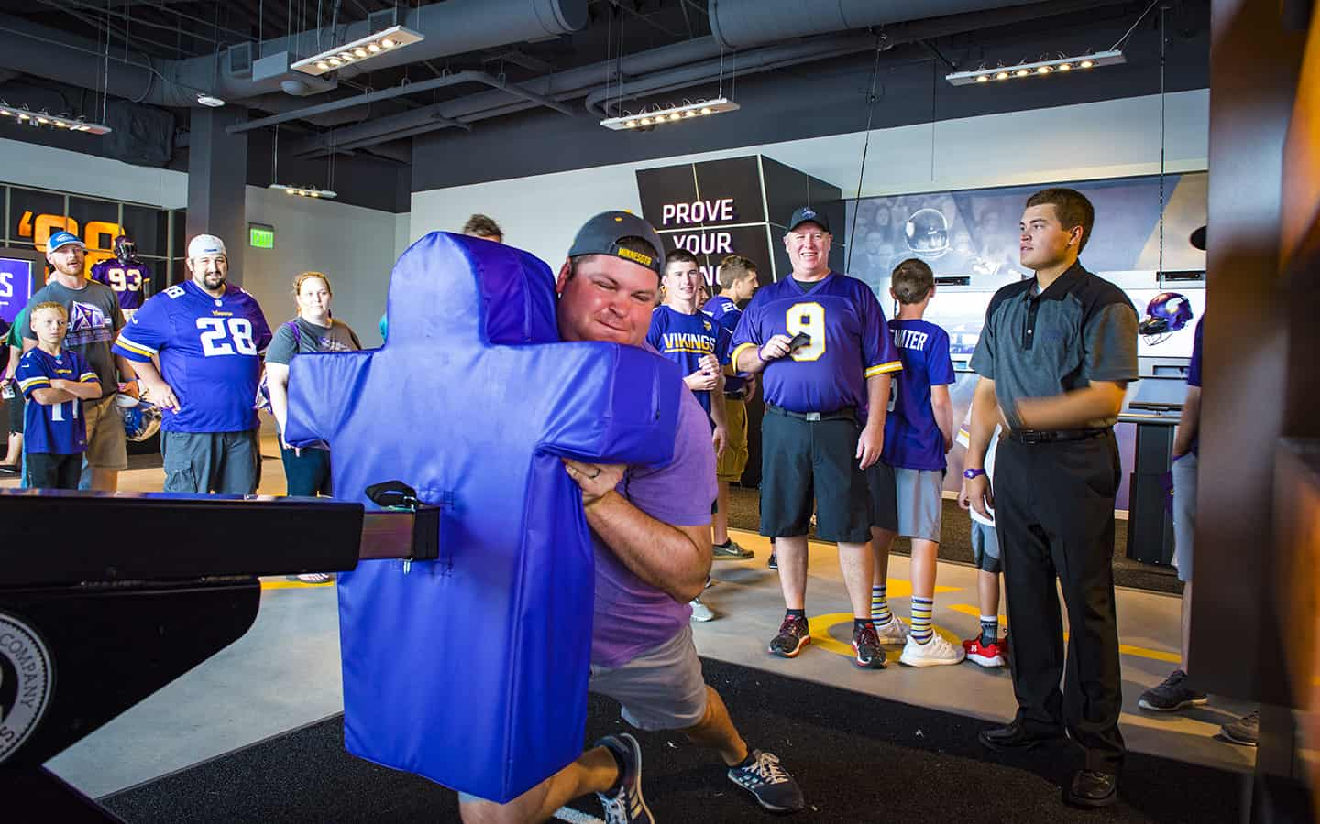  A Viking fan undertakes a good old fashioned  tackle in the Vikings Hall. | 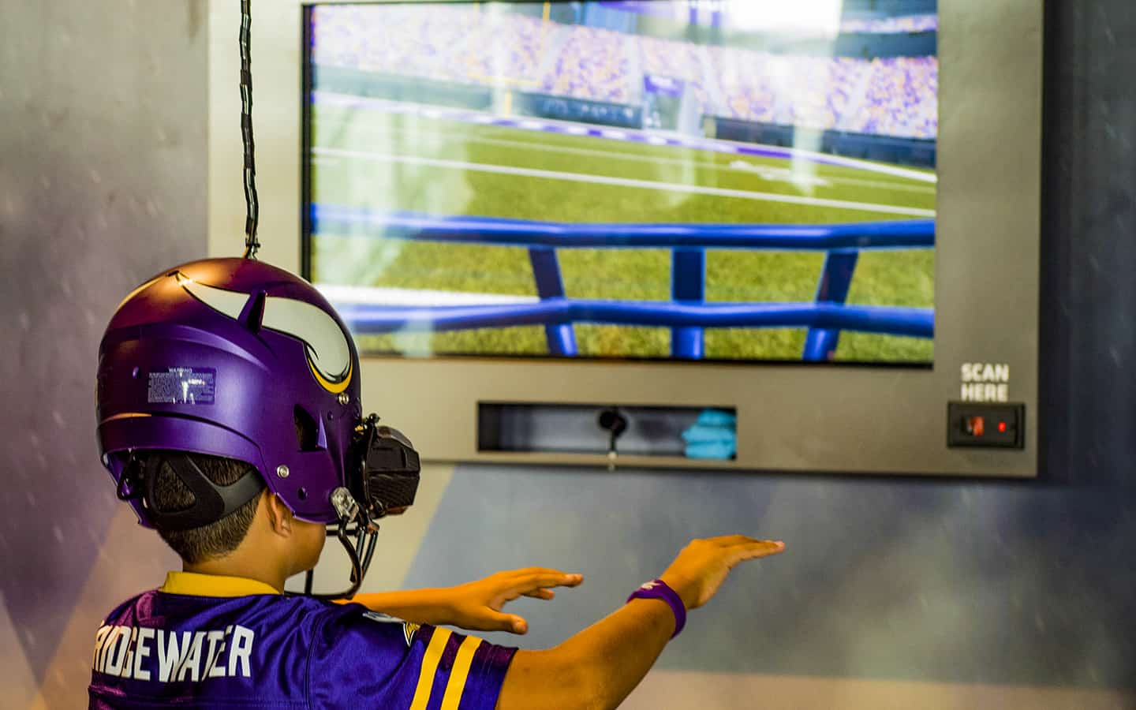  A young Vikings fan negotiates the field  using the virtual reality helmet

DI Foundation

Part of DI’s culture was being a good citizen within its community. As DI’s website put it, “Giving back to the community that has given us so much.” To that end, Trotter initiated the Dimensional Innovations Foundation. The company website explained:

Supporting our community isn’t part of our business plan. It’s a part of each and every one of us. Kansas City isn’t just our location. It’s our home. And we have a fierce commitment to make it an even better place to live than it already is. While financial contributions are a key part of giving back, we also give our time and talent. We consistently roll-up our sleeves to support causes that are important to our DI family, leveraging the unique talents of our group.

The Foundation matched donations that company employees made to worthy causes in the KC area. CEO Trotter explained that that the company was “…dedicated to community development… In the last several years we started the DI Foundation which is an internally run group. I have a say, but just a little piece.”

CEO Trotter initiated the Foundation shortly after the child of one of the DI employees was diagnosed with Spinal Muscular Atrophy (SMA). Through the Foundation DI employees had, for example, helped with Jadon’s Hope Foundation to build beds for children with SMA, raised significant funds to support the National Multiple Sclerosis Society, and partnered to honor veteran’s and their families. They had also established social media experience to support the Kansas City Heart Walk and Heart Ball.

The 3D LSAM Challenge

COO Collins noted that DI’s manifesto was “The world is full of mediocre experiences. We help our clients create remarkable ones.” In terms of the future technologies, kinds of projects and clients, CEO Trotter pointed out that the company had been described as “Label-defying” He and Collins knew that in the past DI had gone in unanticipated directions and both felt that the experiences with the LSAM would be no different. However, both CEO Trotter and COO Collins knew they would have to develop a plan for their entry into the 3D printing industry. That would involve identifying business opportunities for the company’s biggest investment yet --- the Thermwood LSAM.

Dimensional Innovations - Appendix A
Company Timeline 1993-2017*

1993: Schofield Design, Inc. founded by Doug Schofield, Jim Baker, Walter Grimes and Jim Richardson
1995: First multiplex with AMC
1997: Move from signage to architectural details and columns
1999: Buyout of Schofield design accompanied by new name, Dimensional Innovations. New brand. Tucker Trotter becomes partner.
2001: Commitment to digital fabrication
2002: Walter Grimes & Jim Richardson retire. Change of banking relationship and first sports job. Cessation of theatres building trend. Diversification of DI clients and capabilities. First project of new era: San Antonio Spurs Arena
2003: Addition of retail, health care, museum and metalwork. Start of 3D Sculpture.
2009: Start of Innovation Lab
2010: First technology job. Project at Oak Park Mall in southwest KC metro area. Company decision to avoid bid business.
2011: Addition of new departments: Interior design. Branding. Greater emphasis on design. Writing of Red Vision Book
2012: Shield CaseWork initiated (See Appendix #F: Internal Ventures and Spinoffs: Shield Casework and Rockbox.)
2014: Jim Baker’s retirement. Establishment of DI Foundation and Rockbox, DI’s video subsidiary business (See Appendix #F).
2015: Completion of Lincoln (NB) Bridge Project**
2016: 2020 vision session with resulting emphasis on DI design-build, technology team begins to build rapidly.
2017: Expansion into additional space in Lenexa, KS

*DI (2017). Dimensional Innovations (Privately distributed volume focusing on highlights in the company’s history. Published in honor of Jim Baker).

** The Lincoln Bridge project was a pedestrian bridge completed in 2014. Called “The Haymarket Bridge”, the span connected the Pinnacle Bank Arena in Lincoln, NB to a nearby parking lot. The bridge was almost two blocks long and had an estimated traffic of 6,000 people on game days. The bridge included bold lettering of the city’s name, bright lighting, and depiction of the city’s values using associated quotes from famous Nebraskans. The Lincoln bridge, a bridge like no other (2014, Aug. 19). Dimensional Innovations (Accessed at https://www.dimin.com/blog/the-lincoln-bridge-a-bridge-like-no-other/, 3/10/19)

Dimensional Innovations - Appendix #B
DI’s Senior Executives

  University of Kansas, BFA. | Tucker Trotter, President & CEO  Tucker Trotter was recognized as the driving force behind the success of Dimensional Innovations (DI) success. He joined the firm as an intern in 1995 and, essentially, never left. After graduation he spent short stent as an entrepreneur with Outdoor Innovations. Outdoor had a full line of consumer products for the automotive industry. Many major retailors distributed the company’s main product. The firm owned multiple patterns. As DI’s senior executive and chief architect of its success, Trotter was noted for his emphasis on collaboration, commitment to partnering with clients and other strategic partners, involvement in a wide range of

projects, and applications using DI’s continually expanding capabilities. He had used his insight and firm to encourage internal ventures such as Shield Casework and Rockbox.

In the Kansas City community, Trotter was involved in multiple activities and organizations focused in encouragement of entrepreneurship, philanthropic endeavors, and other local community issues. His activities included service on the UMKC Henry W. Bloch School of Management’s Regnier Institute for Entrepreneurship and Innovation Advisory Council, the Shield Advisory board, Trustees of the Fredrick J. McCoy Endowment Fund for the Cleft and Craniofacial Clinic at Children's Mercy Hospital in Kansas City, the Boy Scouts Heart of America Council Board of Directors, and (previously) the Center of Architecture and Design-AIA Kansas City. In 2016 Trotter was a member of the American Heart Association Executive Leadership team for the Heart Ball.

Beyond Kansas City Trotter was involved in the Young Presidents Organization, mentored many young professionals, and served previously on The Society for Experiential Design Board of Directors. He was an honored University of Kansas alumnus; supported the KU Center for Research; and served as Vice-Chairman on the Dean’s Advisory Board for the School of Architecture, Design, and Planning. Trotter was acknowledged as one of Kansas City’s most accomplished business leaders including recognition in Ingram’s “40 Under 40” and his selection as a Kansas City, NEXTGEN Leader.
Tom Collins, Chief Operating Officer/Principal  As Chief Operating Officer, Tom Collins led Dimensional Innovations’ strategic growth and client-facing operations. In this role, he was responsible for coordination of activities across the entire corporation. During his almost five years with DI, Collins brought multiple talents, experience, and insights including driving operational results while focusing on customer and employee outcomes, managing diverse workforces and project teams, assessing strategic alternatives, developing sales strategies and compensation plans, improving operational/production planning, leveraging supply chain efficiency, and project management. His background in |  |   Notre Dame, BBA Accounting
finance and accounting brought expertise in turnaround plan development and implementation, mergers and acquisitions, acquisition integration, financial forecasting and budgeting, treasury management and cash flow optimization, and design and implementation of accounting and financial controls.

Beyond DI, Collins was involved in education as well as focused on kids and cancer. He served as Board Member and Treasurer of Supporting Kids Foundation. He was also active with the UMKC Henry W. Bloch School of Management’s Case Competition Program.

Previously: Had almost two decades of experience as a finance and operations executive in public and private companies in addition to Big Four consulting experience. Roles included CFO, Hooper Holmes, Inc.; Senior Vice President of Operations, Hooper Holmes, Inc.; Principal, Preferred Finance Partners; and Finance Manager, American Italian Pasta Company.

Dimensional Innovations – Appendix #C
DI’s Six-Phase Design-Build Process

ACTION | PHASE | TOOLS | DELIVERABLES | BUDGET
1. | LISTEN | DISCOVERY SESSION | DISCOVERY  CREATIVE BRIEF  STORY | ESTABLISH BUDGET  Good, Better, Best Options  BUDGET  BRACKETING
2. | DREAM | DESIGN EXPLORATION | CONCEPT OVERVIEW  CONCEPTUAL DESIGN | BUDGET CHECK  ± 25%
3. | FILTER | DESIGN REFINEMENT | -SCHEMATIC -DESIGN  -SAMPLES  -MOCK-UP TESTING | BUDGET CHECK  ± 10%
4. | DEFINE | DOCUMENTATION | DESIGN DEVELOPMENT | BID TO BUDGET  with Shopping List of Options  and Contingency  ± 5%
5. | LAUNCH | BUILD +  INSTALL | PROJECT EXECUTION  FINAL 1% | CLOSE-OUT
6. | MAINTAIN | SERVICE + REFRESH | -TRAIN  -SERVICE  -MAINTAIN  -ADAPT
Adapted from: Dimensional Innovations Overview: Experience Design – Profile + Process + Work. Dimensional Innovations internal document.

Dimensional Innovations - Appendix #D
Experiential Design/Experience Design/User Experience Design (UX, UXD, UED or XD)

The field of experiential design (ED) involved multiple phases of designing, building, installing, and testing product, services, processes, events, and environments that placed priority emphasis on the quality of the user’s experience. The field traced its roots to the 1940s as individuals and companies became more conscious of the importance of the systems aspects of the interactions between humans, machines, and environments. The approach involved many disciplines.

The approach was exemplified by the Society of Experiential Graph Design (SEGD), a non-profit professional association that described itself as “a multi-disciplinary community creating experiences that connect people to place.” (www.seg.org). The organization was:

…(a) global, multidisciplinary community of professionals who plan, design, and build experiences that connect people to place… (and included) graphic, information, media, interaction, exhibition and industrial designers, fabricators, architects, technology integrators, brand strategists, students, wayfinding specialists, teachers, and others who have a hand in shaping content-rich, experiential spaces.

SEGD had its roots in the early 1970s and had grown to over 2K members from 35 countries with 34 chapters throughout the United States and also in Canada and Australia. The organization had established Standards of Professional Conduct (https://segd.org/file/2016-12-08segdprofessionalstandardspdf). SEGD’s held its annual conference in various places and had established a set of awards given annually in a number of categories.

SEGD explained that the activities undertaken by its multi-disciplinary members were the research, planning, designing and building of “…diverse range of visual communications and information systems for the built environment…” that included “…static and digital wayfinding systems, signage, environmental graphics, exhibition content, multimedia installations, public art, user interfaces and branded/corporate environments.” (https://segd.org/what-we-do)

Experience design sough to develop the experience of a product, service, or event along any or all of the following dimensions:

- Duration (Initiation, Immersion, Conclusion, and Continuation)
- Intensity (Reflex, Habit, Engagement)
- Breadth (Products, Services, Brands, Nomenclatures, Channels/Environment/Promotion, and Price)
- Interaction (Passive < > Active < > Interactive)
- Triggers (All Human Senses, Concepts, and Symbols)
- Significance (Meaning, Status, Emotion, Price, and Function)

Source: Steve Diller, Nathan Shedroff, Darrel Rhea (2005): Making Meaning: How Successful Businesses Deliver Meaningful Customer Experiences. New Riders Press ISBN 0-321-37409-6]

Dimensional Innovations - Appendix #E
Profiles of Four Sets of Trends Identified by DI and Selected DI Projects

Dimension Innovations served clients from a number of industries. In 2017, DI explored trends in four broad markets the firm expected to have significant potential in the near future ---

E-1. Employee experiences (in contrast to traditional office space)
E-2. Sports experiences (professional and collegiate)
E-3. Healthcare (wellness vs. illness)
E-4. Entertainment experiences (that would resonate)

Below are synopses of DI’s insights into the current situation into each and the expected trends. Also included are profiles of selected projects and the partner groups involved in the projects.

E-1. Employee Workspace Design – Redesigning for Experience vs. Office Space

DI recognized the importance of workplace environments for employee recruiting, turnover, and health issues related to stress --- not only for DI itself but also for customer companies. The low unemployment rate had led to competition for top talent, especially among Millennials and Gen Z. Bloomberg estimated that U.S. businesses lost $11B per year because of employee turnover. Companies expended as much as six to nine months of the salary to recruit a replacement when an individual left the company. For a $40K salary that cost was $20K to $30K for recruiting and onboarding including training. In the middle of the Twenty-first Century’s second decade, the average worker spent about ten years at work with about 150 sq. feet allocated for workspace. Workers reported stress as their biggest health issue. Thus, almost sixty percent of companies reported investing more in their employer branding for recruiting purposes.

Millennials (those born between 1982 and 2004) made up nearly a third of the U.S. workforce and over 85% had moved into management as they took on roles from which Baby Boomers were retiring. The Millennials looked for their jobs to provide something beyond the paycheck --- a job that would inspire passion, contribute to society, and fit their life styles. Further, they were more willing to change jobs and companies than previous generations.

Indications were that there was more emphasis on transparency, unconventional workspace with open and collaborative spaces, a variety of spaces that could accommodate individual workspace as well as meetings for collaboration, the presence of greenery such plants, and a backlash against “corporate” goals that stressed the company’s performance rather than the well-being of its people. Expectations were that firms would move to increasing use of smart building technology, emphasis on healthy workspaces including LEED certification (Leadership in Energy and Environmental Design), workplace legibility (ability to see and find others as well as clarity of the purposes of workspaces), and “homestyle comfort”. These aspects included at least five design elements: visual access, landmarks (interior or exterior), architectural differentiation, space confirmation or layout, and signage.

DI identified Dr. Michael O’Neill of Haworth, Inc. as an authority regarding workplace designed. Haworth was a major designer and manufacturer of a wide variety of office furniture and related materials. According to O’Neill, companies would need to begin to adapt for the oncoming Generation Y. Generation Y was described as “much more collaborative and motivated by the need for social connection… (and demanding of) choice—over the location of their work and the options of spaces to use.” To accommodate, companies were finding blurring between the traditional spheres of life, i.e., home and office, work and play, public and private. Company buildings are increasingly adding a multiple types of space in the workplace including “…rooftop gardens, intimate lounge areas, and cafés to game rooms and meditation centers.” The result was complexity that often led to ambiguity in how a particular workspace should be used.

Further, a significant portion of the workforce was still Baby Boomers with their increasing challenges with eyesight, hearing, and mobility.

A DI project in Employee Workspace Design: Legibility - Dairy Farmers of America (DFA). DI pointed to the 110K sq. foot new headquarters for Dairy Farmers of America as an example of an award-winning building that was on the forefront of legibility. The DFA organization had outgrown its leased seven-story building that was composed of 175 traditional office spaces. Senior management wanted to design a workplace environment that would reflect the needs and desires of the employees who worked for the 20-year-old marketing cooperative. The cooperative included 14.5K members from all over the U.S., almost a third of the companies and individuals involved in the milk and milk-derived products industry.

The initial design process included 15 “engagement committees” each of which focused on a different issue such as meeting areas, the café, workspace cubicles, and amenities including a fitness center. DFA wanted to make sure that the design supported its employees’ efforts to support DFA’s membership. Other contributors to the building were the Architecture + Design Firm HOK; Branding and Artwork design/build firm Dimensional Innovation; encompass, the local dealer for Michigan-based Haworth Furniture Dealer; and General Contractor JE Dunn, all of the greater Kansas City area.

The resulting design was a $30M three-story building with largely open-space with just 10 private offices. The DFA headquarters building was located in Wyandotte County, KS in the northwest area of the Kansas City metro region. The building designed included a variety of space configurations. The branding engagement committee established the purpose of the branding design. The committee felt that DFA’s branding should reflect the entire scope of the activities undertaken by DFA members -- farms, processing facilities, and consumer dairy products used worldwide.

The centerpiece of the branding for the organization that created the “Wow” factor in the lobby was the DI-designed two-story, 25-foot milk-pour sculpture. DI made the “pouring milk” of foam to which the company applied high-gloss lacquer that hardened the foam.  Creation of the design for the milk sculpture took time. DI designers and artists visited a local dairy farm to get a feel for many aspects of milk farms. They studied how milk flowed from a pitcher. They poured multiple glasses of milk, took photos, made sketches, and used 3D modeling software to fine-tune the design. In addition, they studied other firm’s approaches to branding and their buildings. In addition, the client, the architectural firm’s team, and the DI teams worked on a collaborative basis. They shared ideas, models, renderings and coordinated their materials | 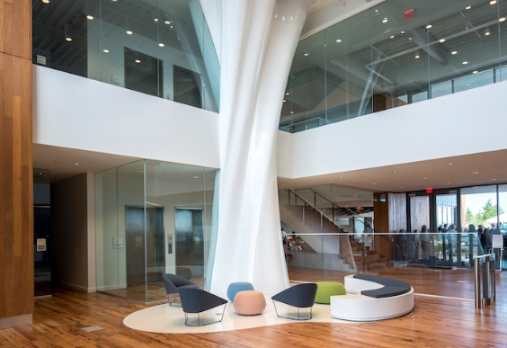  DFA’s Milk Pour Sculpture  Photo courtesty of Dimensional Innovations (Alex Grisby)

palettes to yield the resulting design and its implementation.

Other players in the $30M project were VanTrust Real Estate LLC, developer; HOK, architect; Lutjen, civil engineering; Bob D. Campbell & Co., structural engineer; Lankford-Fendler + Associates, MEP engineer; JE Dunn Construction, general contractor.

E-2. Sports – Reinventing the Experience for Fans, Sponsors, Owners, and Players

DI recognized that sport fans could have their best game-day experiences seated in their own homes. The company’s aim was to assist owners, sponsors, and venues to provide in-seat stadium and arena experiences to “get those fans in (physical) seats”. The big challenge was how. The basics in stadiums included food, drinks, lounges, WIFI, and charging stations. However, highly ranked stadiums offered more. The Mercedes-Benz Stadium in Atlanta, home of the Atlanta Falcons football team, reported increases in attendance for 2017. Team owner Arthur Blank had taken several steps. More than a third of Falcons’ fans had indicated that the food and drink services needed enhancement --- The stadium dropped prices by 50% and found fans coming earlier and average spending per fan increasing 16%. Indeed, they came early to take advantage of food and beverage options.

Other aspects of modern fans that the industry recognized included:

- Shorter attention spans existed among Millennials and Gen X fans.
- Phones, tablets and 4G enlarged the fan experience to 24/7
- Fans interest went beyond the sports season.
- Fans demands for more engaging, immersive experiences bringing them closer to the action, athletes, stats, and other aspects of the sport (in short to bring the fan to as close as possible to an insider’s view)
- Fans motivations including escape opportunities from the everyday, bonding with family and friends, connection to a larger group of fans, watching highly skilled athletes, learning with and from other participants, and sharing team achievements.

DI identified major trends as:

- Sponsors aimed at integrating their brand experience with the event so there was greater chance fans would feel connected with their brands.
- Fans used social media actively while at games including posting while watching.
- Pre and post-game experiences were also important. These entertainments needed to engage fans.
- Occupants of stadium seats needed to feel the specialness of participating in an exclusive event and, at the same time, the event needed to be inclusive of a wide range of diverse audiences.

To that end DI knew that sports teams and stadiums would need to utilize state-of-the-art technology to create “wow” experiences. Examples included holographic representations, representations of players, wayfinding to entries/exits, food/beverage purchase in one RFID bracelet, and e-Sports (i.e., live streaming that is often preferred by Millennials and Gen Z).

The Mercedes-Benz Stadium in Atlanta opened officially in August of 2017. The stadium used a new technology called the Partner Portal. The Partner Portal system had the ability to collect data for and feed that data to sponsors.

DI sponors projects. The DI projects included the Viking Voyage space and the Mercees-Benz Stadium.

The Viking Voyage space in the US Bank Stadium in Minneapolis included significant appeal to fans including interactive games, tracking and posting of scores with RFID technology, and opportunity to learn about Vikings history. The interactive in-situ experiences were available before, during, and after each game.

The Mercedes-Benz Stadium in Atlanta GA included opportunities for design of sponsor spaces. Kansas City-based architectural firm Populous won the initial architectural design contract in 2011 with an estimated cost of $700M. The final design had an estimated cost of $1.2B. St. Louis-based HOK, the largest U.S.-based architectural-engineering firm, submitted the final design. The stadium was the home for the Atlanta Falcons football team and the Atlanta United FC soccer team. The Partner Portal enabled the stadium sponsors to switch displays depending on a football or soccer team was playing because the audiences for the two sports had different preferences. The stadium owner hired DI to work with each sponsor to design the sponsor’s display. DI oversaw the entire project for each sponsor from concept to completion.

Justin Wood, Principal and Sports practice Director for DI, explained:

What we really like about this is that it creates a holistic approach to the entire stadium experience, tying it all together. What we really wanted was each sponsorship activation to be different, so we could entice people to get out of their seat and walk around the stadium to try out the other areas, which is a hard thing to do. But with each sponsor offering unique experiences, it’s much more enticing…When a sponsor is telling their brand story in their space, it ties cleanly to whatever is happening that day. If it’s an Atlanta Falcons game, you feel like you’re at an NFL stadium. If you are at an Atlanta United game, you feel like you’re at an MLS game. Heavy utilization of technology makes that possible…The demographics data shows that the crowds for various events are extremely different, so it’s important for sponsors to adjust their activations depending on which group is there.”

The AT&T Perch and Family Insurance were two sponsor examples in Atlanta. The AT&T area was a coveted seating area in which early arrivers could watch coverage of the current game or the activities of their other favorite teams on 114 screens. The American Family Insurance zone was located on concourse 200 level. It was designed to inspire fans to “Dream Fearlessly” with inspirational kiosks with downloadable screensavers, and an ever-changing Dream Mosaic, column graphics, and over-sized “Atlanta United” jersey and Atlanta Falcons helmet.

In terms of exclusivity, the Gullwing Club at the Mercedes Ben Stadium provided complementary food and beverage services for members. An example of inclusivity included the Cleveland Indians Kids’ Clubhouse at Progressive Field, in Cleveland, Ohio. The Cleveland Club provided physical and interactive play with high-touch and high-tech activities that connected ages two to twelve to their team.

E-3. Healthcare: Designing Experiences for Wellness vs. Illness

DI recognized that U.S. healthcare presented opportunities. The ever-advancing technologies were often difficult to incorporate within aging facilities. The expanding needs of the Baby Boomers demanded attention to age-related chronic diseases. DI recognized that design of space to encourage employee engagement was critical since medical errors were responsible for more deaths than the other leading causes, i.e., heart disease and cancer respectively. There was also indication that pediatric healthcare environments were “incubators for hospital design innovation.” Among possibilities were the use of virtual reality in patient treatment. Studies had indicated that virtual reality could be effective in the treatment of pain relief especially among children. Children did better if their chemotherapy treatments occurred while they played games than when they were asked to rest.

DI Healthcare Projects. DI had completed projects at the University of Iowa Stead Family Children’s Hospital and in Children’s Mercy Hospital in Kansas City.

DI had completed the project at the University of Iowa Stead Family Children's Hospital in February 2017. The project involved creation of an immersive children's theater in the new hospital’s lobby. The theater had two interactive games, the "Eagles' Flight" and "Story in the Stars". DI designed the eagles game to have participants start in Iowa and use their arms to control a bird flying across the United States. Along the way, the game participant saw various landmarks such as Mount Rushmore. The stars game involved three original stories that brought to life constellations in the night sky. As the story was ongoing, the participants could interact with on-screen hot spots to discover animated elements within the each scene. The stars game had four unique voiceovers resulting in greater variety of experiences for repeat game users. The exhibit could accommodate up to four young people at one time. Among the benefits to the young patients were encouragement of movement, which distracted the children from their pain and promoted healing.

The hospital’s Child Life Specialist noted, "What I really love about this space, especially as a child life specialist, is that it's adaptable for people of all ages, abilities, and disabilities."

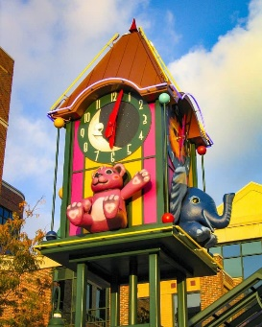  The Clock Tower at Children’s Mercy Hospital Downtown Campus | DI had worked with Kansas City-based Children’s Mercy Hospital since 2003. The Hospital, established in 1897, was a regional medical center. It was well known for its treatment of and research and medical training related to diseases and health difficulties affecting those from newborn to age 21. One DI projects was the clock tower that greeted visitors in circle drive of the hospital’s downtown campus. Throughout the interior’s multiple facilities were elements such as carved and painted kid friendly trees, cars, and bears. DI had found that “The trick (was) always been to find a blend of fun and durability for these whimsical and highly used areas.”
The architectural and construction firms selected DI to help provide a “wow” factor for the renovation of the hospital’s 5000 square foot gift shop. Among the “wow” features were the rainbow ceiling that included both color as well as curved arching. DI had been the launchpad for Shield Casework that had developed award-winning attention in the healthcare industry for its cabinets and other furniture. This DI subsidiary figured prominently in the gift shop renovation. | 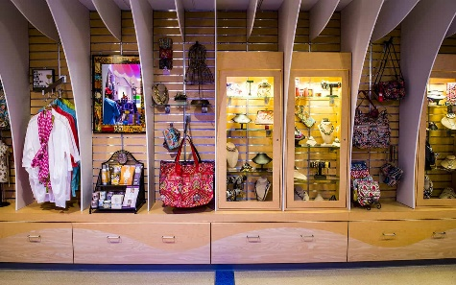  Shield Casework display cabinets and  display area “fins” in the Children’s Mercy gift shop
Up until early 2018 DI had not been aggressive in the healthcare area, but had accepted projects as they came the firm’s way. However, CEO Trotter noted:

There is a buzz throughout the health care industry from the work we've done, which drove us to bring Jessica Morrow on board and have someone dedicated to this space instead of the more passive way we've been approaching this up to now… We're just really excited about using technology as a way to speed up healing, reduce the need for sedatives and pain management drugs…If we can design and create a great experience that allows patients to escape their current reality and have a better experience, we know that's going to help healing. That's really fulfilling.

Newly appointed in 2018 as Healthcare Practice Leader, Morrow expressed her thoughts about the potential:

There are great opportunities for us to install interactive features like the one we did in Iowa. It gives the kids a destination to go to within the hospital. We've got feedback from the team at the University of Iowa that it is encouraging kids to move in ways they normally wouldn't, which helps them to heal faster. We're also seeing virtual reality take off, since it’s been proven in a lot of studies to lessen the need for pain medication, because it's distracting the kids and lowering their anxiety levels.

DI’s expectation was to build a team around Morrow that would devote its attention to marketing and design in health care.

DI had been involved in other healthcare related projects that included Virtual Reality including Bravemind. Bravemind was a type of virtual reality therapy that focused on helping veterans and others suffering from PTSD.

E-4. Entertainment: Designing Moments that Resonate

DI noted that the “Experience Economy” reflected a trend among Millennials to spend on experiences rather than material goods and a similar trend was occurring in Gen Z. Live event spending has continued to increase since the late 1980s while electronic word-of-mouth (E-WOM) was the preferred way for users to find experiences. As DI put it, “Entertainment is now a mix of the latest technology, storytelling, and an experience that they won’t soon forget.” DI identified three types of entertainment trends --- traditional, immersive, and festival.

Traditional types of entertainment. DI noted that traditional types of entertainment could include resonating designs in restaurants and movie theaters. For example, DI completed a project that turned the Omaha-based Alamo Drafthouse motion picture theater interior into a “Star Wars” mecca in time for the theater’s opening. The lobby in particular was themed as the original Star Wars trilogy and the theater’s grand opening occurred just prior to the opening nights for the opening of the newest Star Wars movie. On the theater’s exterior were sixteen- foot-tall, LED-lit lightsabers. The concession stand was designed with a space station-inspired decor and the theater had Imperial-style light panels and directory signage within its silver-black-and-gray corridors. Another feature aspect was the Emperor Palantine’s chair that provided photo ops and "fired" a laser from the fiberglass fabricated Death Star. A button on the Emperor Palantine’s chair "fired" a laser from the Death Star with its LED green lights and interior sound system all of which was suspended above the floor of the lobby.  The project included Architectural partners, ELEVATIONarchitects, and general contracting partners, NCB. | 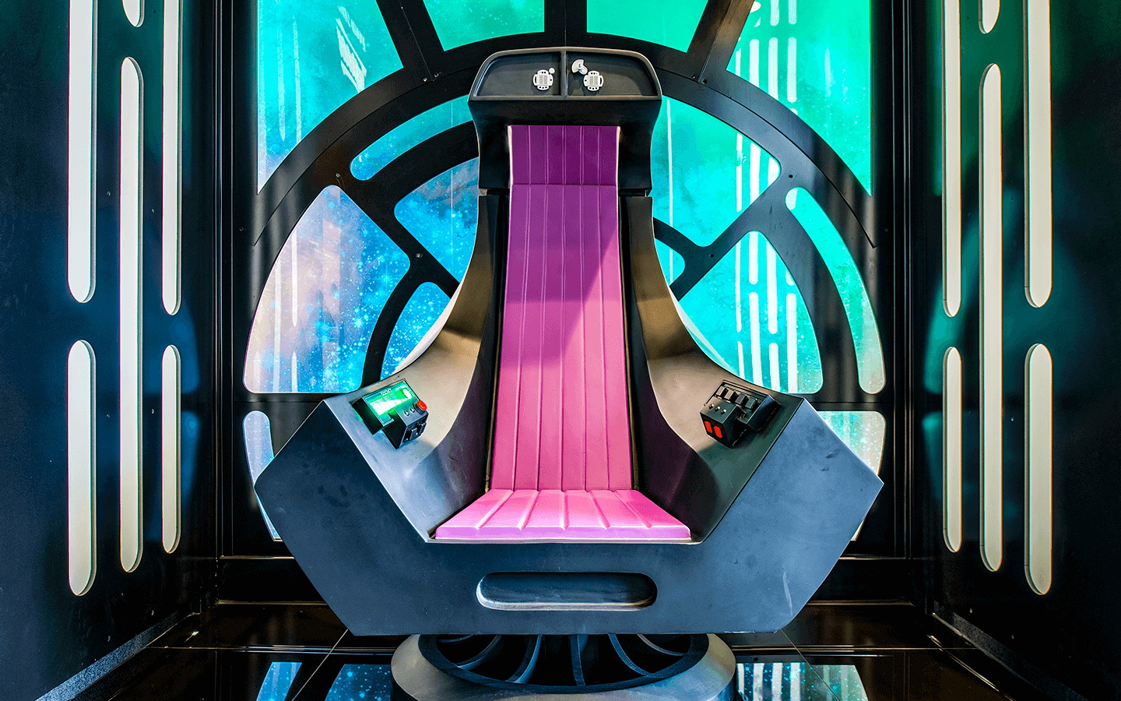  Photo op - Recreation of villain Emperor Palantine’s throne with control for “firing” the operational-yet-  non-dangerous “miniature” Death Star.
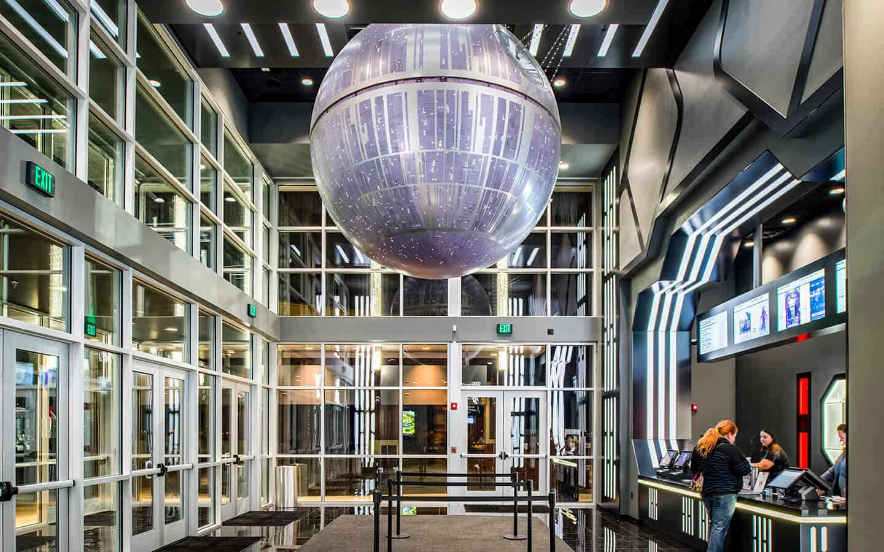
Death Star space station hanging overhead in
the center of the theater’s main lobby.
 | Alamo Drafthouse, Omaha “Star Wars” Themed Lobby Pictures
Immersive Entertainment. Immersive entertainment covered a broad variety of venues including escape rooms to full-themed immersive parks. The venues could include experiences that were physical or digital. DI noted that the defining feature was that “they were created with the human viewer at the center of it all.” One example in which DI was an integral player was the Evel Knievel Museum.
The museum was the brainchild of Mike Patterson, third-generation owner of the Historic Harley-Davidson Topeka dealership. Along with two other owners of the museum, Patterson invested $3M in the museum. The dealership added 16K square feet to accommodate the museum. The museum, which opened in May 2017, housed the largest collection of Knievel memorabilia in the world. Among the items are six of Knievel’s bikes, more than a dozen of his original leather costumes, helmets, fan letters, X-Rays, and photos. A major display was the custom-built 1974 Mack Truck “Big Red” that Knievel used to haul his bikes around the country. The custom-built truck included Kneivel’s living quarters. The truck came to Topeka because the owner was dissatisfied with the restoration progress being made in New Jersey. He made contact with Patterson who engaged as many as 90 people in the restoration.
DI created the interactive exhibits in the Museum. They included a custom 4D virtual reality jump experience, an interactive Jump Planner and a “Bad to Bones” injury explorer. The jump experience included a sit-on bike, custom helmet that the visitor used. Through Virtual Reality, the visitor could experience a recent jump undertaken by another stunt motorcycle rider Doug Danger. That jump involved going over 16 police cars with the wind blowing. As the bike “lands”, the bike seat “kicks”. An attendant accompanied every “rider” because some visitors had leaned over so far during the ride that they fell off!
Several of the interactive exhibits incorporated STEM lessons. The interactive ‘Jump Planner’ exhibit immersed the user in details involved in planning the jump including the angle of the jump, speed of the bike, and wind resistance. The Planner enabled visitors to determine if the planned jump would meet with success. The ‘Bad to the Bones’ interactive display involved the visitor to view Knievel’s failed jumps. The display included old videos as well as photos showing the exact bone broken.
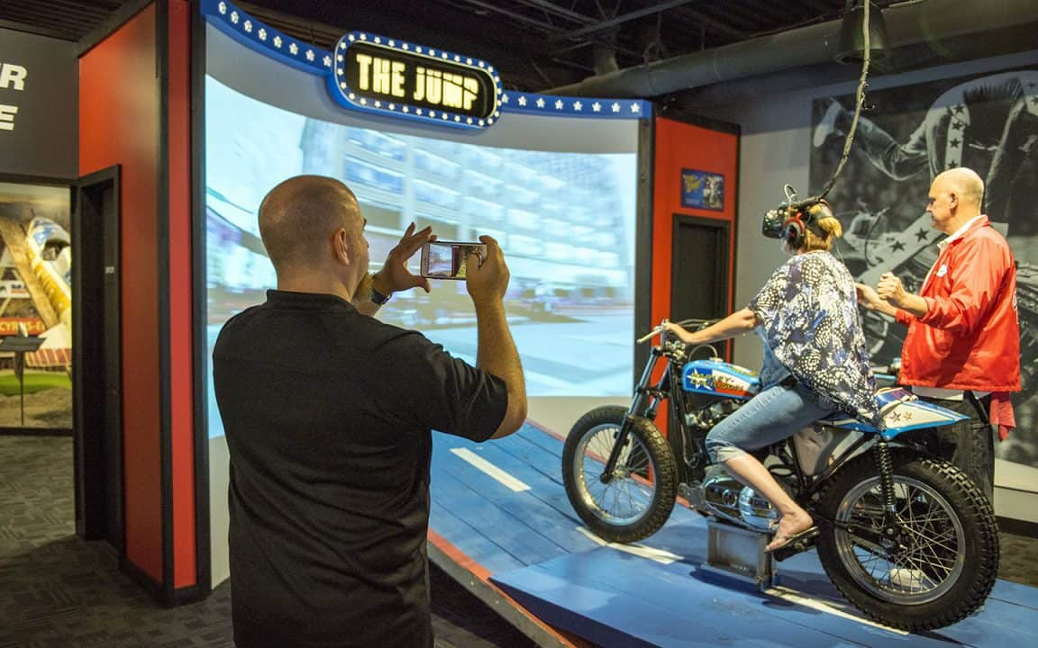  The Virtual Reality Jump at the  Evel Knievel Museum, Topeka, KS  (Photo courtesy of Dimensional Innovations) | 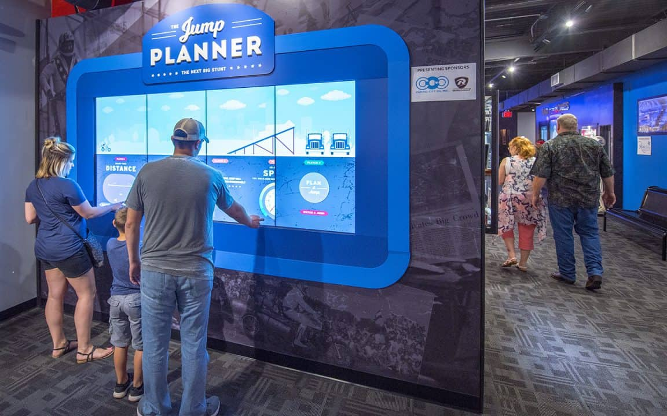  The Virtual Reality Jump Planner  at the Evel Knievel Museum, Topeka, KS  (Photo courtesy of Dimensional Innovations)
Festival Entertainment. DI observed that that music festivals were moving to immerse audiences before and after the event itself, not to mention enhancing experiences during the event. One example was the Boulevardia guitar at the Boulevardia Fest.

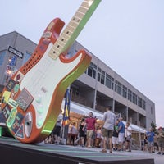  The Boulevardia Fest Guitar  (courtesy of Dimensional Innovations) | The Boulevardia Fest was a two-day festival in central Kansas City. Organizers came to DI for “something big, iconic and interactive for the over 40,000 people entering the welcome center”. The result? ---a 12-foot, 500-pound guitar that allowed visitors to select among 16 buttons to designate major and minor keys in “clean” or “dirty” mode. Once the Boulevardia visitor touched the strings, the guitar would play guitar sounds that the sound (actually borrowed from GarageBand). The DI team of designers, electronic engineers, fabricators, and installers completed the design, fabrication, and installation in less than five weeks. One of the challenging aspects of the design was installing the guitar at a playing angle with no visible supports.

Dimensional Innovations - Appendix #F
Internal Ventures and Spinoffs - Shield Casework and Rockbox

In addition to its innovations within its mainstream business, DI had also internally generated two other firms that by 2019 were freestanding businesses --- Shield Casework and Rockbox.

Shield Casework. Shield Casework initiated in 2011 in DI’s Innovation Lab. The Lab was trying to create an illuminated sink that would light up in order to encourage handwashing. The designers created multiple prototypes and each time had to prop the sink on sawhorses. They investigated a solid base for the sink prototype. However, they found that most solid surface bases were imported. The imported bases were of lower quality than the design team needed to display the new product, and they were non-customizable. The team decided to develop a base that would reflect the effort they were expending in the sink design. After experimenting with various materials, DI settled on a hard impervious plastic counter top and eventually built a complete case or cabinet of the same material for the sink.

When DI displayed the sink to potential buyers, the buyers were impressed. However, they were even more interested in the cabinet with its clean, durable and stunning solid surface that was easily cleaned. This aspect was especially important to the hospital market because the casework helped in reducing bacteria on surfaces, bacteria that was well known to contribute to widespread problems with hospital-borne infections. The material was described as:

…a Space Age material made from acrylic polymers and alumina trihydrate that can take seamless shapes and comes in a variety of colors. It's a material as versatile as wood, but more durable and easy to sterilize. It's also less expensive than stainless steel.

After 20 weeks using the results of trial and error and input from focus groups, DI developed the desired casework. The firm worked on details such as connections, the construction process, and the coved interior corners. The company submitted patents on these aspects of the cabinets and also worked on details such as hinges and its sanding process.

Founder Baker talked about why casework (i.e., cabinets) was so attractive to hospitals:

Your conventional laminate top, over time, it will delaminate, and those areas are easy to become out of reach of your cleaning chemicals and become contaminated. Our product line eliminates that. If it does become contaminated, wiping it down thoroughly cleans it.

We’re primarily focusing on the health care industry to start…But there are opportunities on college campuses and places like that because besides being easy to clean, it’s just so durable. Its lifetime is significantly longer than particle board, so it’s cost-effective.

In January 2014, DI created a separate company called Shield Casework. By yearend, Shield had already generated $3M in revenues. In 2015 Shield exited from the 20,000 feet it was using in DI’s central building and moved into a 20,000 s.f. leased facility in North Kansas City. Stephen Hopkins headed the company as President. Hopkins graduated from KU with a B.A. Architecture in 2005 and then his MBA at UMKC in 2013. He had worked as a Commissioner for Kansas City, MO Environmental Management Commission for almost five years prior to joining DI as Director of Innovations in 2011. By 2019, Shield had won numerous international awards for its designs. As Shield’s website put it:

We’re not just building a better box anymore. Our philosophy is simple: we create beautiful products that are meticulously crafted, immaculately clean and unmatched in quality. We live in a space where beauty and function meet. Think Italian design meets German engineering. It’s more than fabrication: it’s care and customization, great design and 100-percent transparency.

Potential markets for Shield Casework included any industry that needed cases/cabinets or flat surfaces. Shield’s products could replace laminate and pressboard because it was more durable and easier to clean and stainless steel because it was less expensive. Shield Casework’s initial primary market was health care with cabinets/casework and headboards. The company’s products were also in use in hotels and retail shops, as athletic lockers, and for products in hospital surgical rooms.

RockBox. RockBox had somewhat different origins. The founders, Rom Demetriou and Tim Kail, came to DI CEO Tucker Trotter with ideas about a video business. At the time, DI had freed-up space from the exit of Shield Casework. The used the space to create a laboratory for research and development of new technology and house a new spinoff video business called RockBox.

Trotter, Demetriou and Kail founded RockBox in 2014. Trotter brought his significant network of business contacts as well as his business acumen and success. Demetriou and Kail had marketing and video production experience. Kail explained that when he began freelancing in 2010 he found that:

…a hybrid creative person was going to be the future of video production…The key was someone who could do a lot of different things. It was all about making the production model tighter and more efficient. It's kind of how the idea for Rockbox came up.

The first Rockbox production was a four-minute video for DI that interested parties could view on the internet or that the firm could e-mail to potential clients. The purpose of the video was to present DI’s brand that could explain the company’s multiple capabilities in a fun way. As Demetriou put it, that video:

…gave us a proof of concept that we could tackle a marketing challenge and create a piece of video content that could be high impact…That is a marketable skill. The sales people at DI will tell you this video helped change people's perception of DI…You can't just say we need to make video and then put out a boring video no one is going to watch, or worse than that, put your company in a bad light because of the poor quality of the video…You can't suck. People are harsh judges. The quality of your content is judged against a really high bar.

In underscoring the importance of quality video, Demetriou pointed out that 70% of Internet bandwidth was used to watch videos. That data convinced him that the future of successful brand advertising was in high quality video. RockBox embraced that challenge by combining skills found in advertising companies --- conceptual thinking, captivating storytelling, as components of dynamic marketing strategies --- with the capabilities of a production company produces high-quality video content. The firm’s skills won it the business of major clients such as “…Microsoft, which also used the agency for its Xbox One and Bing businesses, Helzberg Diamonds, H&R Block, the University of Kansas, the Minnesota Vikings, Molson Coors and others.”

The firm developed video on the following six principles that it developed in its work with clients and “…in strategy sessions with Google”:

#1. Constantly reward people for their time.
#2. Be entertaining or useful, or both.
#3. Attention spans expand and contract.
#4. Style is an investment.
#5. Commit to a moment in time in the conversation.
#6. Ready. Fire. Aim.

ENDNOTES

